**2 Dimensional Arrays Activities**

**Cabinet2**

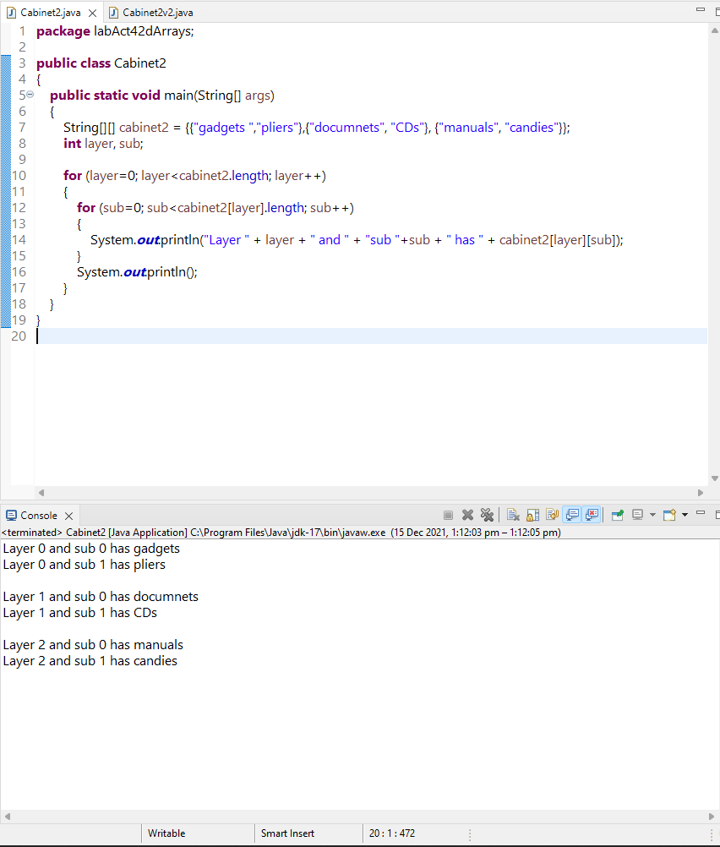

Video Link:  
<https://drive.google.com/file/d/15Wgo4HIW3LdF-KP9y6ONYzPEmUAs0N7e/view?usp=sharing>

**Cabinet2 2nd Version**

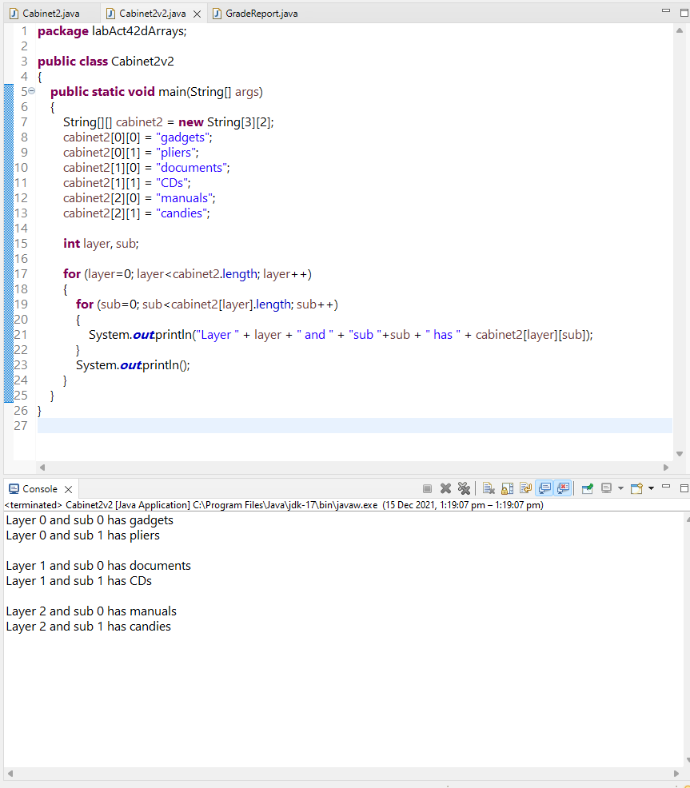

Video Link:

<https://drive.google.com/file/d/1twZBMRHiyOSN0JOJyZuUjpfXyEkZgIOp/view?usp=sharing>

**GradeReport**

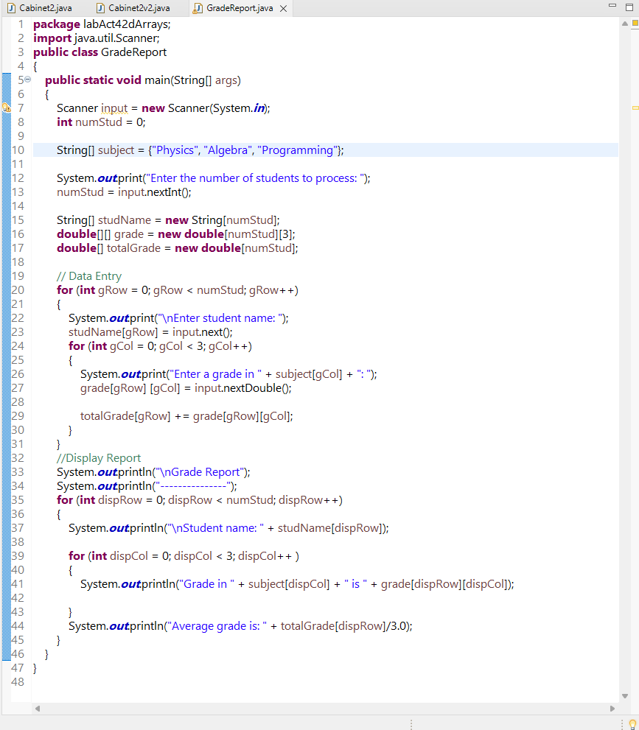

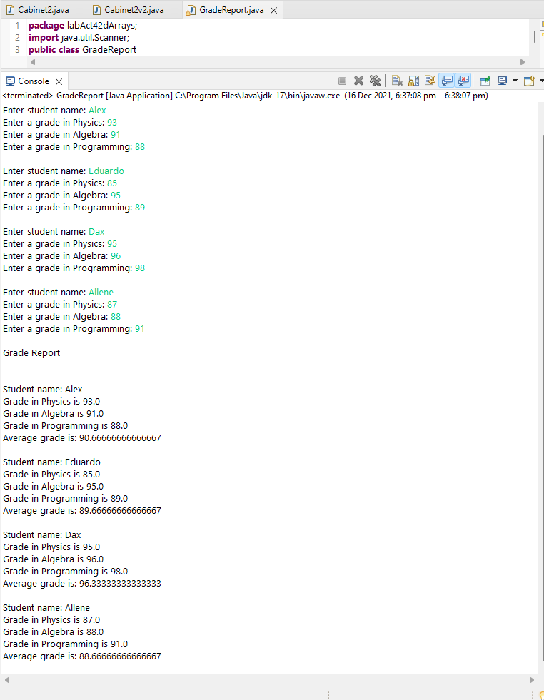

Video Link:  
<https://drive.google.com/file/d/1Fqbc8e1pMEkRa1gy0vF3-XSpxQh6soih/view?usp=sharing>